SmartLink™ SL-4-AC Installation Guidelines
Sustainable Technology for Remotely Monitoring and Controlling Digital Field Assets

Contact: OutdoorLink Technical Support
(256) 885-9768
support@outdoorlinkinc.com

OutdoorLink, Inc. recommends during the installation of SmartLink units, all electrical codes that apply to the wiring and troubleshooting of these units, are studied, and adhered to. Electrical code varies by area, so please verify local electrical codes prior to installation. SmartLink units operate in a high voltage environment. OutdoorLink, Inc. assumes no liability for any injury or death incurred during the installation of the SmartLink unit.

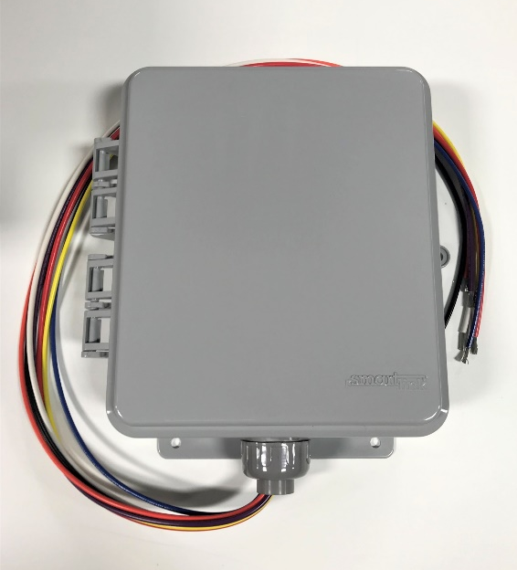
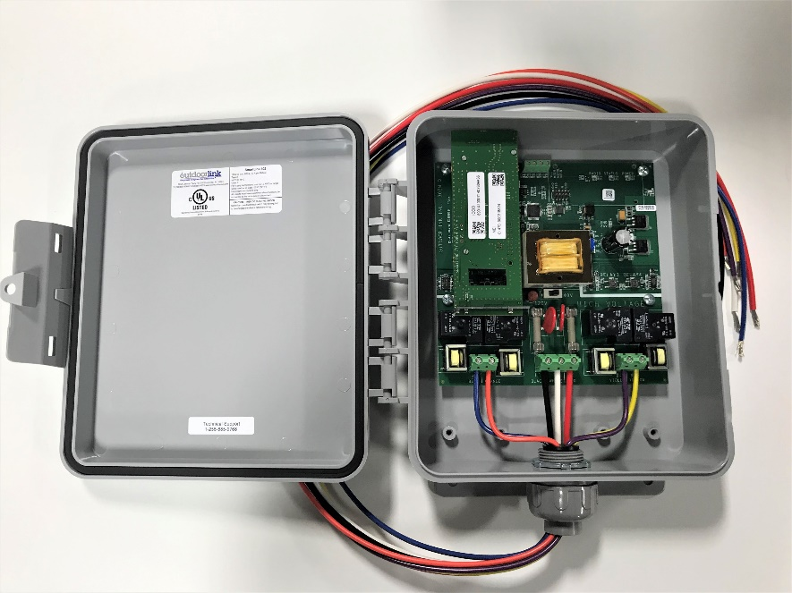

SmartLink™ SL-4-AC Installation Guidelines
Below are technical specifications, installation guidelines, and a wiring diagram for the SL-4-AC controller. OutdoorLink provides 24/7 technical support, so please call (256) 885-9768 or email support@outdoorlinkinc.com with any questions.

SL-4-AC Technical Specifications

Device Management | 4 relays to manage 4 AC powered devices
Enclosure | Polycarbonate, 10.5 in. x 9 in. x 3.25 in.
Input Power | 30A max @ 120-240V per relay pair, 50-60Hz
Output Power | 17A per relay
Power Consumption | 0.13A max @ 120V
Connectivity | Cellular 4G LTE Cat 3, internal SIM, integrated antenna
Operating / Storage Temperature | -40°C to 75°C
Wiring Connection | 3 ft. wiring harness, 10 AWG supply and 12 AWG load wires
Testing | Manual push button per relay
Tools & Materials Needed (not provided)
- Wire crimper
- (4) 1/16” diameter screws
- (4) male / female quick disconnects
- 1/4” diameter padlock or other securing device
- Ladder (recommended)
- Voltage meter (recommended)

Planning the Installation
- Two supply lines are needed to utilize all 4 relays of the unit; one for relays 1 and 2, and the second one for relays 3 and 4.

- Each supply line is fused at 30A. If more than 30A of fixtures are to be used, ensure that the second supply line is used, and the load is balanced evenly between relays 1+2 and relays 3+4.

- The SmartLink SL-4-AC unit is designed for single phase 120V or 240V operation and will not be able to meter power on relays 3 and 4 if multiphase power such as 208V three phase (120V line to neutral) is used.

Electrical Service
- The SmartLink is internally fused at 30A on each of the two internal load circuits, protecting the SmartLink unit and the load connected to the unit. Input power can be provided per the following recommendations.

- In most cases it is preferable to use a single breaker if possible, as this will ensure that a single cutoff needs to be turned off for servicing the unit, and it will ensure that the power for all relays is provided by the same voltage phase from the incoming utility service.

- To provide 240V to a fixture, two relays are required. A typical 240V fixture install will combine relays 1 and 3, or relays 2 and 4.
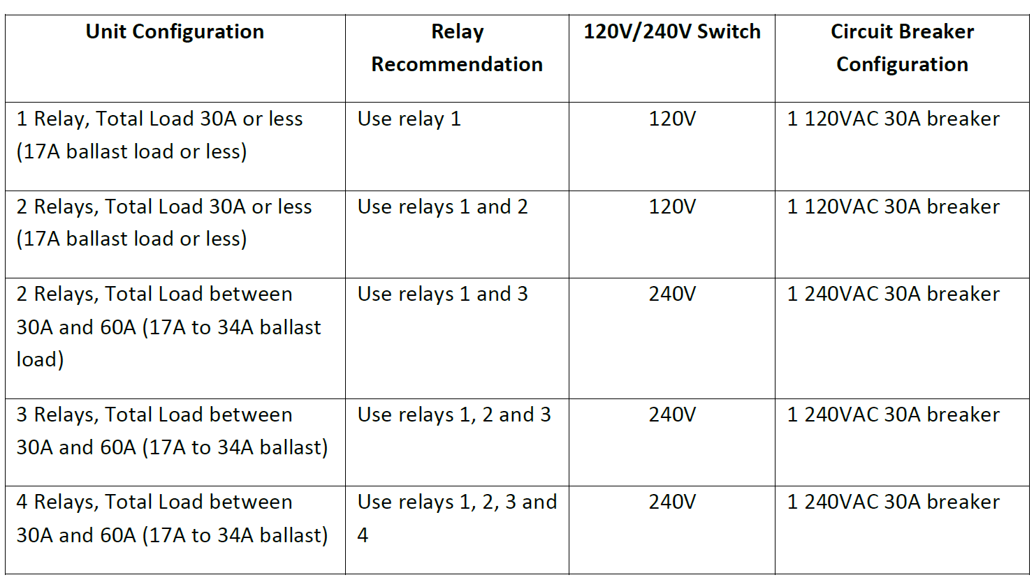

Installation Guidelines
- The SmartLink SL-4-AC operates at 120V or 240V 60Hz, and great care should be taken when opening the door of the unit for service or installation. Do not touch any area of the circuit board below the white line and the text “HIGH VOLTAGE”, unless you have first ensured that all circuit breakers supplying power to the SmartLink unit are in an OFF position. CHECK TO MAKE SURE THAT ALL BREAKERS ARE IN THE OFF POSITION BEFORE WORKING WITH THE SMARTLINK UNIT.

- Choose installation placement and confirm cable lengths are sufficient for making all device connections. The SmartLink should be facing outward and upward for optimal cellular connectivity.

- Place the SmartLink on the chosen location and use as pattern to mark holes for mounting. Mark holes with a marker.

- Drill marked pilot holes with a drill bit.

- Mount the SmartLink using 1/16” diameter screws with washers (not provided).

- Wiring Connections
  - Refer to the wiring diagrams below. These diagrams identify the wires needed for your installation.
  - Check to ensure all unused wires are capped off with wire nuts.
  - Input current must be limited via a 30A breaker or fuse. If the charge controller or power feed limits the current to 30A or less the breaker or fuse may be eliminated.

  - Only one of the positive inputs to the SmartLink is required. The second can be connected to the breaker or fuse, capped off with a wire nut or removed from the unit.

- 120V/240V Switch Settings
  - Refer to this chart to ensure that the 120V/240V switch below the transformer of the SmartLink is set properly prior to applying power.
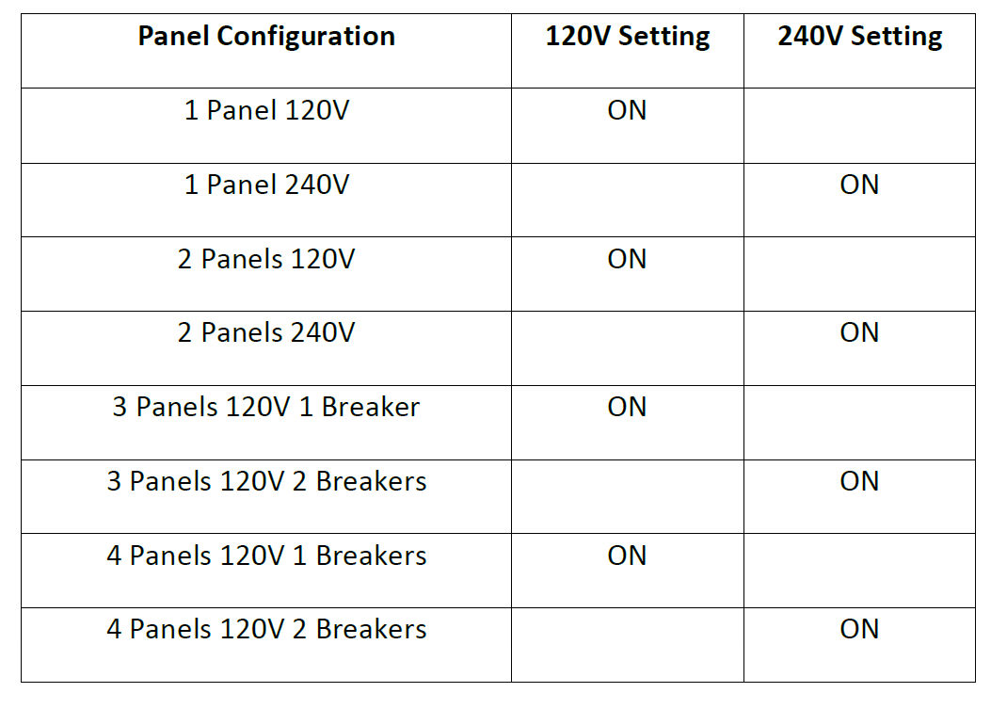

- Documentation and Testing
  - Turn on the breakers.
  - Document the SmartLink unit ICCID or MEID # for each unit installed on the data sheet provided. This number is located both on the mezzanine board and the bottom of the SmartLink unit. (The ICCID # is a 19-20-digit number starting with “89”. The MEID will be an 18-digit value starting with “0x00A”.)
  - Document the structure and each relay’s device on each SmartLink unit installed. Photos should be uploaded to the SmartLink portal for each location.
  - Depress each button at top of each relay to ensure the devices are working. Note: Proceed with caution as there is live voltage around each button.
  - Close the SmartLink™ Unit by applying even pressure on the top and bottom righthand side of the unit.
  - Lock the SmartLink enclosure using a ¼” diameter lock (not provided). Note: the system will send an alarm each time the enclosure is opened after power has been connected to the SmartLink.

- Fuse Replacement
  - The SmartLink SL-4-AC utilizes two fuses with the following ratings. Prior to replacing a fuse, first ensure that all circuit breakers supplying power to the SmartLink unit are in an OFF position.
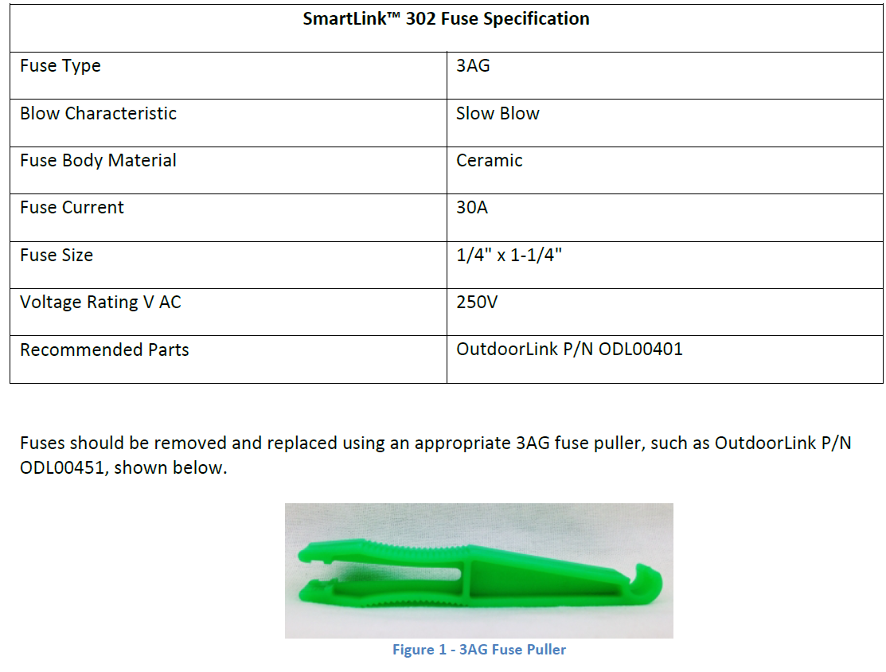

Wiring Diagrams

